Benjamin Apichai
Therapeutics 7
Fibromyalgia
History:
During 1976 the researcher Hench noted the syndrome and for the first time introduced the term Fibromyalgia.
Finally in 1990 the American College of Rheumatology established firm criteria for the classification and diagnosis of Fibromyalgia.
There are over 5 million fibromyalgia patients in the States; it is about 2% population.

Etiology & Pathology:
In western medicine, the causative factor is still unsure.
- some believe it is a malfunction of the central nervous system (Serotonin and Glutamate)
- some in the medical profession thought (the past two hundred years and may still think) as something of psychological nature
- for a while FMS was theorized as an autoimmune disorder. However, once again, research revealed no disturbance of the immune system.
- Finally scientists found, on the FMS patients, the magnesium and cortisol level are lower than normal.
- Under the microscope, capillaries in the muscles on the FMS patients are swelling.
Manifestations:
- Symptoms: widespread pain, insomnia (90%) and inability to fall in deep sleep, fatigue, chronic headache, sleep apnea, poor appetite, abdominal pain and gastric distress, dry mouth, an inability to concentrate, numbness in fingers and toes, widespread stiffness, forgetfulness, restless leg syndrome, depression, anxiety, IBS (30%), severe sensitivity to rain, cold or hot and light, noise and smell.
- Signs: There is no redness, no swelling, not hot and no scar.
- Age: from 18-50 years old.
- Gender: Fibromyalgia affects predominantly women in a ratio of 8:1 or 9:1 compared to men.
- Palpation: extreme pain on tender spots from 4kg force
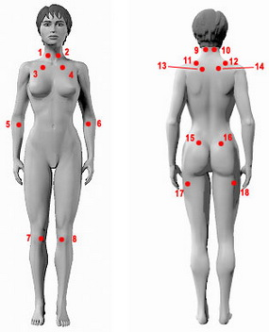
- There is no range of motion limitation
- X-Ray or others: normal

Diagnosis:
In Western Medicine:
Results of joint and muscle examination are normal in fibromyalgia patients, and there are no laboratory abnormalities.
Fibromyalgia is diagnosed by a history of widespread pain for more than 3 months and the demonstration of at least 11 of the 18 tender point sites on digital palpation. However, not all patients with fibromyalgia meet these criteria. Some patients have fewer tender sites and more regional pain, and may be considered to have probable fibromyalgia.

Demonstration of 11 of the 18 tender points
Evaluation:
Forgetfulness 0-3 score
Fatigue 1 week 0-3 score
Restless after rest 0-3 score
Symptoms after rest 0-3 score

Diagnosis if:
5 scores + 7 tender points
9 scores + 3-6 tender points

Differential Diagnosis:

RA- morning stiffness occurs on both RA and FMS. FMS doesn’t show joint swelling and deformity, RA does; RA testing has the presence of rheumatoid factor while FMS shows normal lab tests.

Myofascial Pain-trigger points occur on both FMS and myofascial pain, myofascial pain presents localized stiffness, and patients may not present with fatigue.

Heart Disease-FMS patients present with chest pain, but it lacks of radiation, FMS’s chest pain can not be released by Nitroglycerin and the type and the length of pain are different from heart disease.

Treatment Methods:
In Western Medicine: Pain killers and drugs that anti-seizure, anti-depressants such as Amitriptyline are the methods.

In Chinese Medicine:
1. Liver Qi Stagnation – anxiety, emotional upset, headaches, being easily angered, muscle stiffness in neck and shoulders, insomnia, waking frequently and having difficulty falling back to sleep, dysmenorrhea, premenstrual syndrome, irritable bowel syndrome, anxiety and depression. All symptoms may be triggered by emotional stress.
Tongue: slightly dusky or slightly puffy
Pulse: wiry
Acupuncture points: yin tang, LI 4, LV 3, GB 34, an mian, ren 17, ren 12, ST 25, UB 18, 19, 20
Ear points: shen men, liver, sympathetic

2. Qi and Blood Deficiency –chronic fatigue, exhaustion, dull headache, poor appetite, muscle weakness and numbness, insomnia, dream-disturbed sleep and waking up tired, palpitations, restless leg syndrome, amenorrhea
Tongue: pale, thin white coating
Pulse: thready, weak and deep.
Acupuncture points: LI 4, ST 36, ren 12, SP 6, 10, PC 6, HT 6, 7, Kid 3, and UB 17, 20
Ear points: adrenal, endocrine, heart, spleen

3. Kidney Deficiency –male and female infertility, low back sore, irritable bladder, dysmenorrhea, amenorrhea, hot flashes and night sweats, forgetfulness, dull headache.
Tongue: pale or dry, with cracks
Pulse: thin, weak and deep
Acupuncture points: ren 3, 4, 6, LI 11, LV 2, GB 39, Kid 3, 6, 7, SP6, and UB 23, 31
Ear points: adrenal, endocrine, kidney

4. Bi Syndrome-aversion to cold and rainy weather, patients present with numbness on limbs, patients often complain of swelling fingers/toes.
Tongue: big tongue body and a white and greasy coating on the tongue
Pulse: a tight and slippery pulse,
Acupuncture points: SP 3, SP 10, GB 20, DU 20, ST 36, ST 40, UB 23, UB 17
Ear points: spleen, adrenal, endocrine, heart

Treatment Principle:
- Promote local blood circulation.
- Disperse fluids.
- Remove blockage
- Tonify Qi and Blood
- Stop pain
Acupuncture Treatments:
Addition to the points above, below points are used for each local tender spots according to ACR 18 spots.
Neck Pain: SI 3, UB 10, DU16, Bai Lao
Shoulder Pain: LI 15, Jian Qian, Jian Hou
Arm Pain: LI 11, SJ 5, LI 4
Upper Back Pain: UB 11, UB 17, SI 12
Lower Back Pain: UB 23, UB 25, UB 40
Thigh Pain: SP 10, GB 31, LIV 8
Leg Pain: ST 36, GB 39, SP 6

Auricular:
Shenmen, Liver, Heart, Endocrine, Spleen, Sympathetic

Tui Na Treatment
– This type of treatment becomes very effective beside herbs and acupuncture needling. Many researches show Tui Na on fibromyalgia has significant change
in the pain level, some even consider Tui Na treatment is the main TCM approach for fibromyalgia treatment.

Below is the list of the common techniques used for fibromyalgia:
Grasping Techniques: releases muscle tightness
Kneading Techniques: tonifies Qi and blood
Rolling Techniques: reduces inflammation on the vessels inside the muscles
Chafing Techniques: promotes blood circulation

Seven Star Needle:
Local around the tender points

Cupping:
Local around the tender points

Gua Sha:
Local around the tender points

Exercise:
After the publication from The New England Journal of Medicine — A Randomized Trial of Tai Chi for Fibromyalgia, Tai Chi Chuan has been recognized in worldwide as the most effective exercise in healing fibromyalgia. Tai Chi Chuan not only calms nerves, but also promotes circulation of qi and blood, stretches muscles and tendons to stop pain.
Yoga, Qi Gong and water exercise are also the most pick for fibromyalgia.

Life Style:
Fibromyalgia patients are recommended to fellow below suggestions:
- Establish regular sleep routines. Sleep before 11pm and wake up at 6am.
- Reduce stress. Develop a plan to avoid or limit overexertion and emotional stress. People who quit work or drop all activity tend to do worse than those who remain active. Try stress management techniques, such as deep-breathing exercises or meditation.
- Exercise regularly. At first, exercise may increase the pain. But doing it gradually and regularly often decreases symptoms.

Dietary: Patients need to know what food to avoid or better for consumption.

Foods to avoid:

- Caffeine
- Yeast
- Gluten
- MSG
- Trans fat
- Alcohol beverages
- Carbonated foods & beverages
- Chocolate

- High fat dairy foods
- Fried foods
- Preservatives, junk food
- Food colors and dyes
- Tobacco
- Crabs
- Sugar
- Pork

Foods that recommended:
- Ginger
- Vegetables: recommend-Broccoli; spinach, artichokes, asparagus, celery, yams, sweet potatoes
- Licorice
- Salmon, Tuna, Flounder, shell seafood: lobster, clams, shrimp; liver, small portion of red meat
- Yogurt
- Nuts
- Beans
- Fruits
- Vinegar- Recent research has shown that vinegar is good for lowering blood sugar levels and keeping the stomach slightly acidic, which for me I think helps with food absorption.
- Eggs
- unbleached whole-wheat flour
- pure cane sugar
Ideally all food should be fresh and organic and free from commercial dyes, preservatives and other additives.

Conclusion: FMS is not a life threaten disease, the prognosis is well. Research found those people who have less exercise tend to suffer FMS more than people who have more physical activity. FMS patients who rest more after been diagnosed tend to getting worse than patients keep being busy.
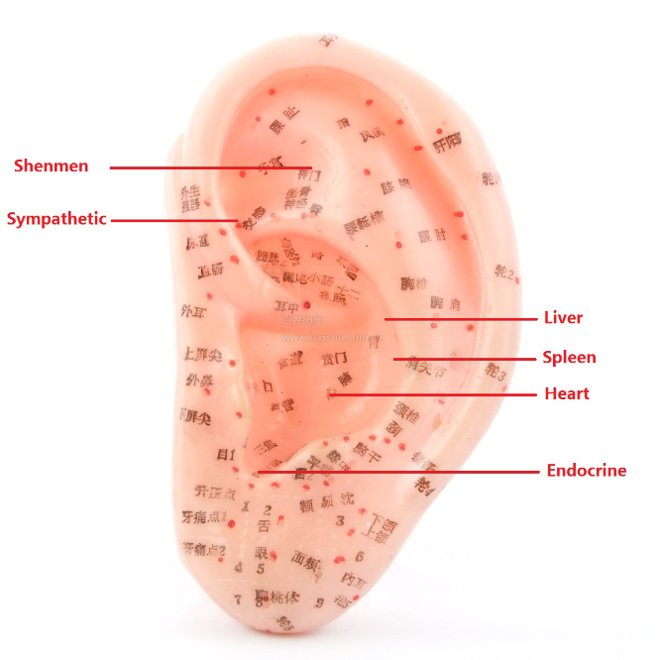
The New England Journal of Medicine — A Randomized Trial of Tai Chi for Fibromyalgia
http://www.nejm.org/doi/full/10.1056/NEJMoa0912611

A Randomized Trial of Tai Chi for Fibromyalgia
Chenchen Wang, M.D., M.P.H., Christopher H. Schmid, Ph.D., Ramel Rones, B.S., Robert Kalish, M.D., Janeth Yinh, M.D., Don L. Goldenberg, M.D., Yoojin Lee, M.S., and Timothy McAlindon, M.D., M.P.H.
N Engl J Med 2010; 363:743-754August 19, 2010
Abstract

Background
Previous research has suggested that tai chi offers a therapeutic benefit in patients with fibromyalgia.

Methods
We conducted a single-blind, randomized trial of classic Yang-style tai chi as compared with a control intervention consisting of wellness education and stretching for the treatment of fibromyalgia (defined by American College of Rheumatology 1990 criteria). Sessions lasted 60 minutes each and took place twice a week for 12 weeks for each of the study groups. The primary end point was a change in the Fibromyalgia Impact Questionnaire (FIQ) score (ranging from 0 to 100, with higher scores indicating more severe symptoms) at the end of 12 weeks. Secondary end points included summary scores on the physical and mental components of the Medical Outcomes Study 36-Item Short-Form Health Survey (SF-36). All assessments were repeated at 24 weeks to test the durability of the response.

Results
Of the 66 randomly assigned patients, the 33 in the tai chi group had clinically important improvements in the FIQ total score and quality of life. Mean (±SD) baseline and 12-week FIQ scores for the tai chi group were 62.9±15.5 and 35.1±18.8, respectively, versus 68.0±11 and 58.6±17.6, respectively, for the control group (change from baseline in the tai chi group vs. change from baseline in the control group, −18.4 points; P<0.001). The corresponding SF-36 physical-component scores were 28.5±8.4 and 37.0±10.5 for the tai chi group versus 28.0±7.8 and 29.4±7.4 for the control group (between-group difference, 7.1 points; P=0.001), and the mental-component scores were 42.6±12.2 and 50.3±10.2 for the tai chi group versus 37.8±10.5 and 39.4±11.9 for the control group (between-group difference, 6.1 points; P=0.03). Improvements were maintained at 24 weeks (between-group difference in the FIQ score, −18.3 points; P<0.001). No adverse events were observed.

Conclusions
Tai chi may be a useful treatment for fibromyalgia and merits long-term study in larger study populations. (Funded by the National Center for Complementary and Alternative Medicine and others; ClinicalTrials.gov number, NCT00515008.)

